**USING RAPTOR – AMSTRONG NUMBER OR NOT**

**FLOWCHART**

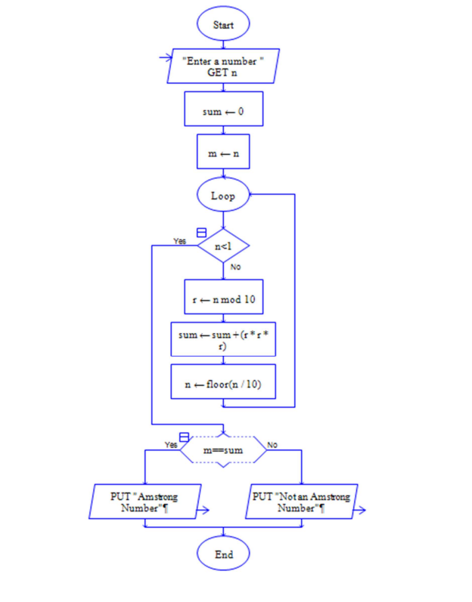

**INPUT**

371

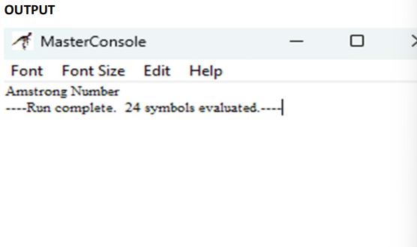

**RESULT:**

The program is executed and verified successfully